
Chemistry 2B
Practical Theory Test
Name:

Score: /15
Instructions to students: Complete on this paper, use of Lab report books allowed.

Part 1: Experiment 26

Write the oxidation and reduction half equations and the overall redox equation for the following: [3 marks]
(If there was no reaction, write ‘no reaction’)

- Chlorine water and KI solution -

Red: 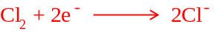

Ox: 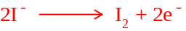

Overall: 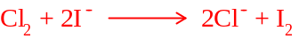

- Bromine water and KI solution - note to teacher – there is a reaction

Red: 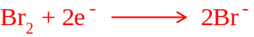

Ox:

Overall: 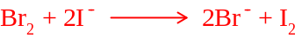

- Iodine water and KCl solution – note to teacher, no reaction

Part 2: Experiment 13

Solutions containing known masses of lead nitrate and sodium iodide where combined to form a precipitate, which was then collected and dried.

- What the precipitate formed? [½]

Lead (II) iodide (PbI₂)

- Predict the mass of precipitate formed in the following [3]

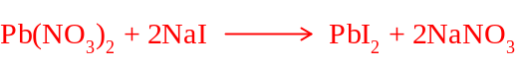

Mass Pb(NO₃)₂ | Mass NaI | Mass of precipitate
1.66g  n = 0.005 | 0.75 g  n = 0.005  limiting | 0.0025 moles produced  1.15g
1.66g  n = 0.005 | 1.35g  n = 0.009  limiting | 0.0045 moles produced  2.08 g
1.66g  n = 0.005  limiting | 2.10g  n = 0.014 | 0.005 moles produced  2.31 g

Part 3: Experiment 22

- Write ionic equations for the reactions between each of the following: [4]
    - hydrochloric acid and sodium hydroxide

    - hydrochloric acid and copper oxide

    - hydrochloric acid and calcium carbonate

    - sulphuric acid and sodium hydrogen carbonate

- Write an ionic equation that describes a successful limewater test. [1]

Part 4: Experiment 23

- Of the metals used in this experiment, which appeared to be the most reactive with acids? Explain your decision based upon your observations. [1]

Magnesium – appeared to have fastest reaction rate

- Of the metals used in this experiment, which appeared to be the least reactive with acids? Explain your decision based upon your observations. [1]

Copper – appeared to have slowest reaction rate

- Write an ionic equation for the reaction between any reactive metal and hydrochloric acid. [½]

For example: preferable to use Mg or Zn

- Write an ionic equation explaining the pop test. [½]

